Dataset info:  
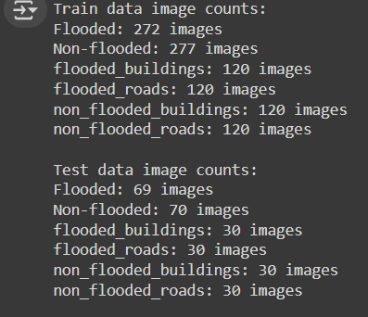

Data viz:  
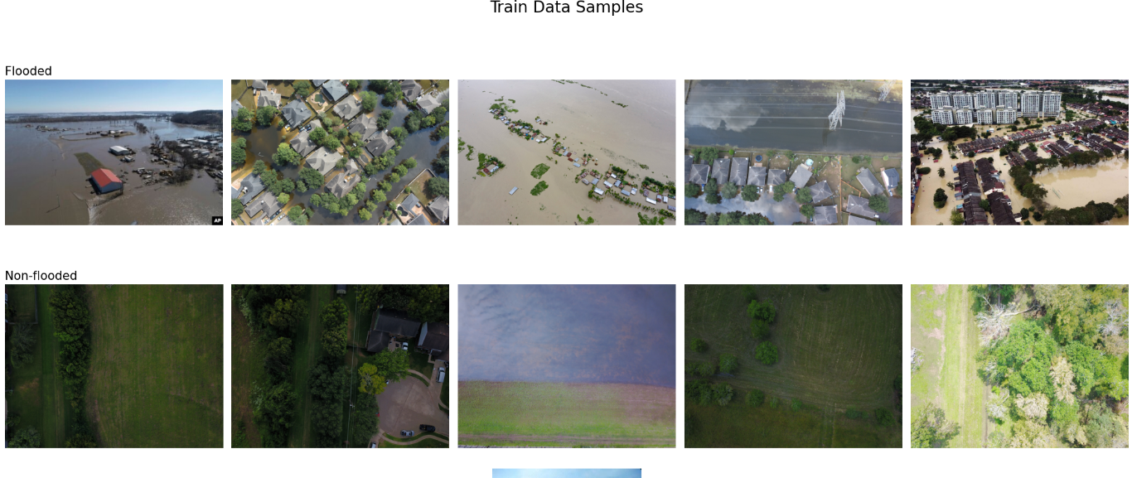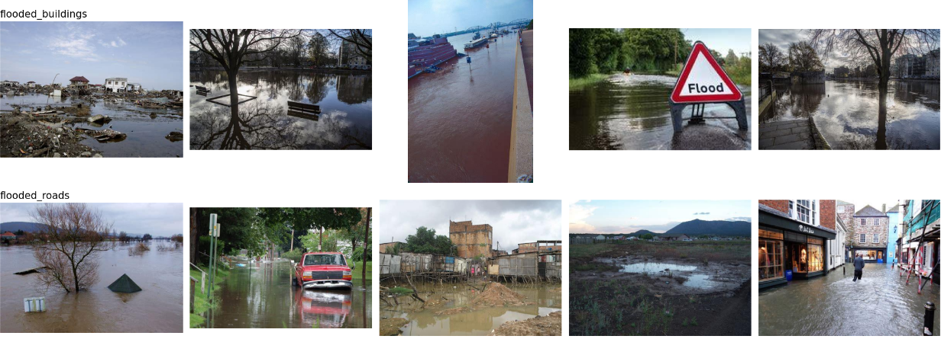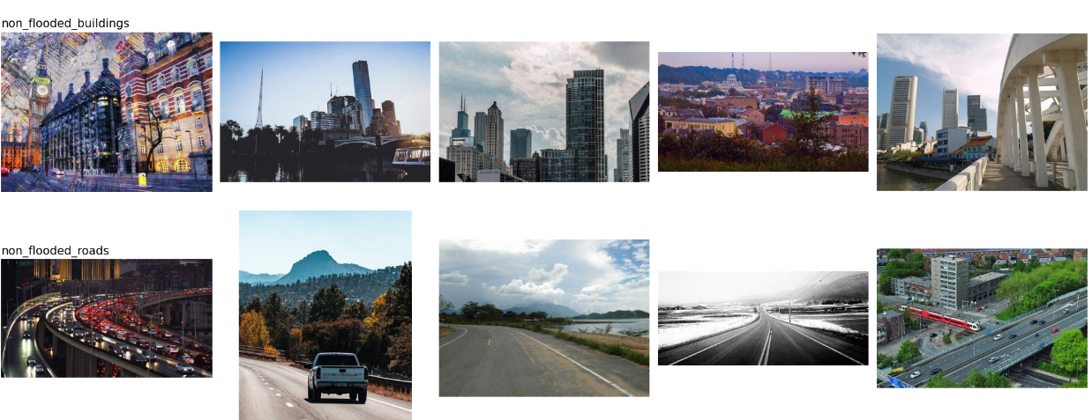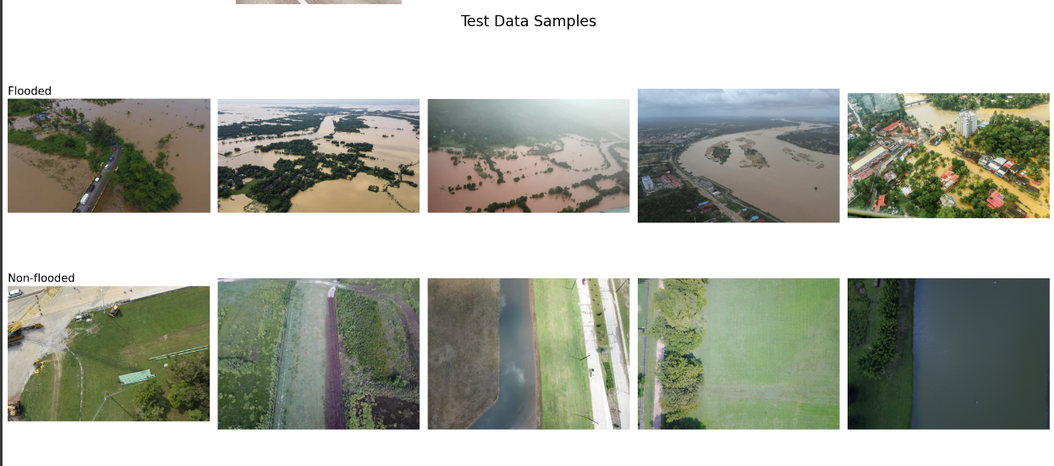

Visualising sample image to understand the vit process

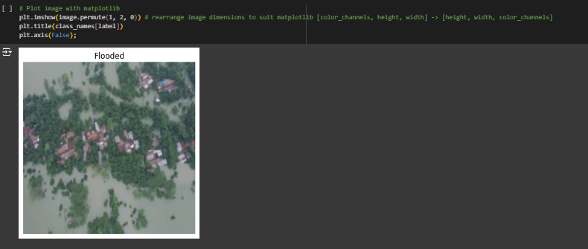

Top row of the patched pixels:  
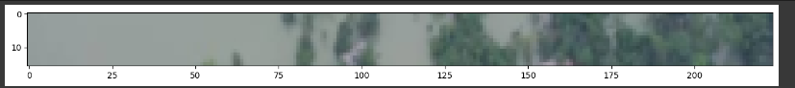

Converting top row of image into patches. PAtch size:16*16  
Image size:224*224

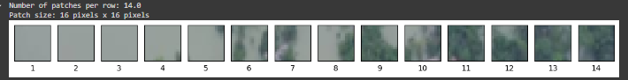

Sample image of flooded region in patch form:  
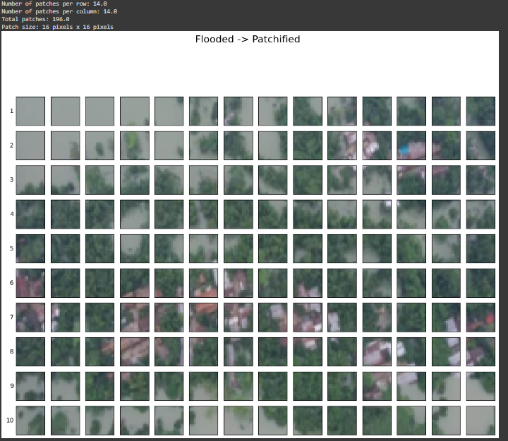

Convolution feature maps:  
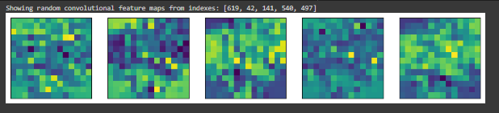

Sample image tensor:  
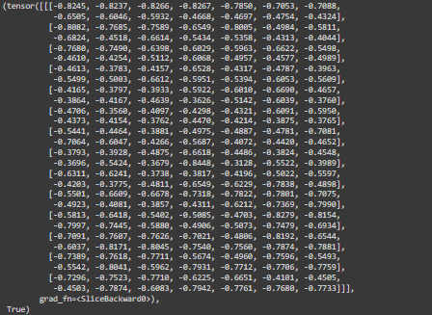

Vit pretrained model summary:  
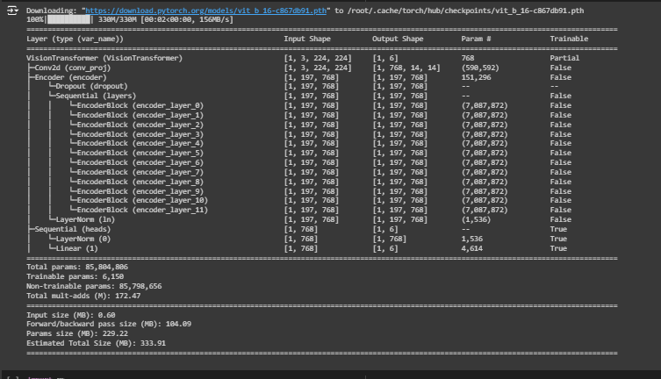

Pre-trained model results:  
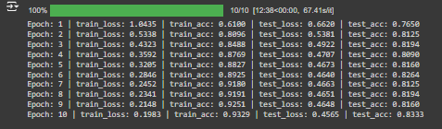

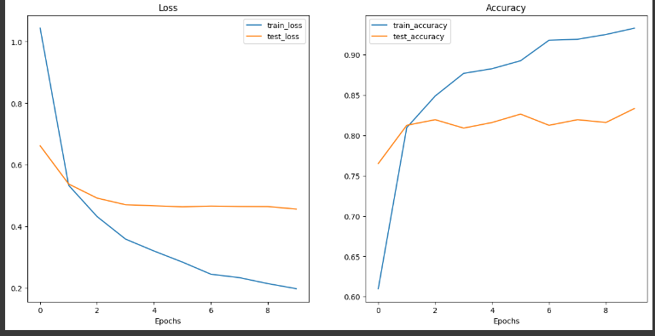

Feature extractor model summary:  
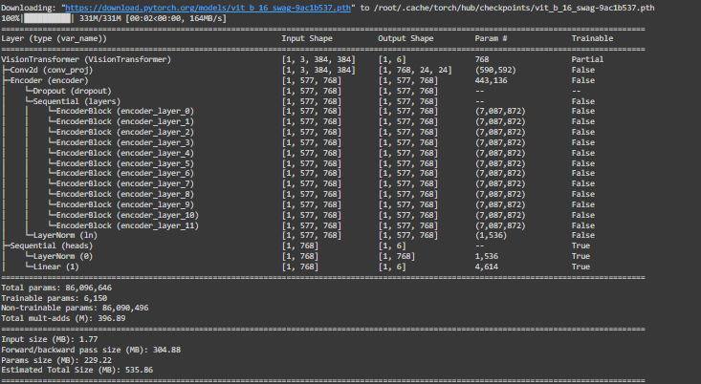

Feature extractor results:

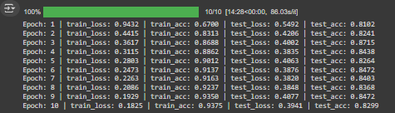

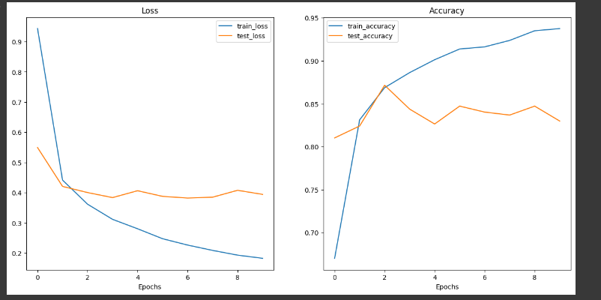

Prediction results:

100%|██████████| 259/259 [00:29<00:00, 8.72it/s][{'image_path': PosixPath('/content/drive/My Drive/dataset/Test/Flooded/1003.jpg'), 'class_name': 'Flooded', 'pred_prob': 0.97699373960495, 'pred_class': 'Flooded', 'correct': True}, {'image_path': PosixPath('/content/drive/My Drive/dataset/Test/Flooded/3014.jpg'), 'class_name': 'Flooded', 'pred_prob': 0.9999102354049683, 'pred_class': 'Flooded', 'correct': True}, {'image_path': PosixPath('/content/drive/My Drive/dataset/Test/Flooded/1002.jpg'), 'class_name': 'Flooded', 'pred_prob': 0.9799307584762573, 'pred_class': 'Flooded', 'correct': True}, {'image_path': PosixPath('/content/drive/My Drive/dataset/Test/Flooded/3082.jpg'), 'class_name': 'Flooded', 'pred_prob': 0.9994576573371887, 'pred_class': 'Flooded', 'correct': True}, {'image_path': PosixPath('/content/drive/My Drive/dataset/Test/Flooded/1064.jpg'), 'class_name': 'Flooded', 'pred_prob': 0.9988495111465454, 'pred_class': 'Flooded', 'correct': True}]

Top 5 most inaccurate predictions:  
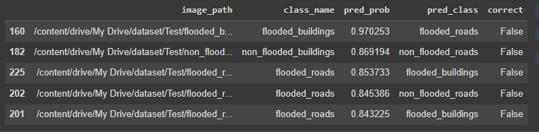

Prediction results:

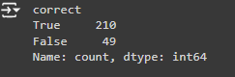

Therefore validation_accuracy:81.08%

Evaluating incorrect predictions:

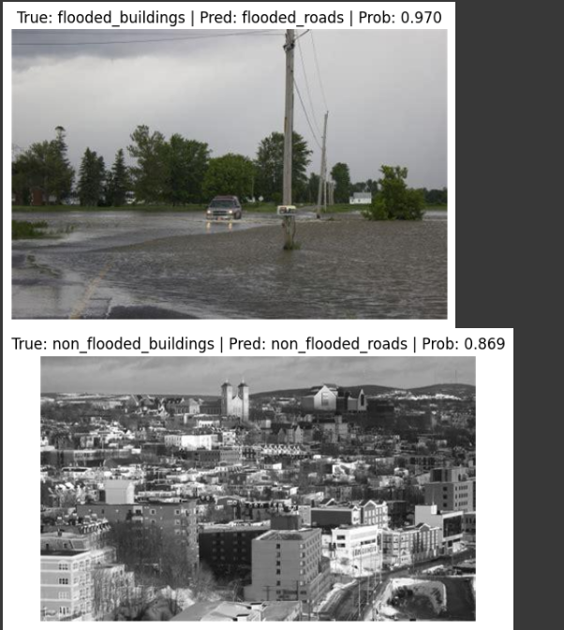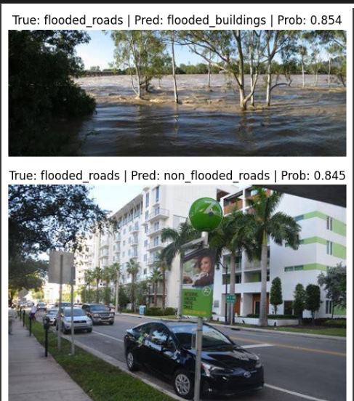

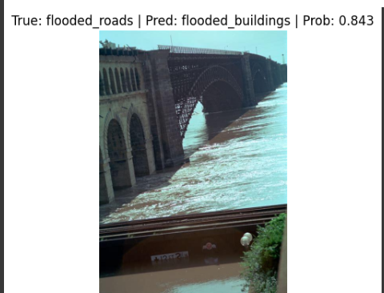

Cause for error identified: incorrect image labeling, model does properly but due to noisy/incorrect data it gives error

Requirement for finetuning, further improving image quality, better labeling,greater separation between image classes.

NExt steps: integrating cnn-vit ensemble model to take advantage of the strengths of both